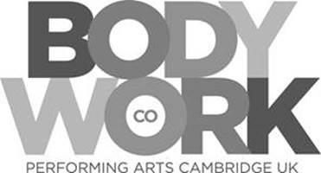

**Autumn Half Term Workshops 2018 at Bodywork Company**

Workshop Requested PLEASE TICK-

**Wednesday 24th October STREET DANCE □**

**Thursday 25th October MUSICAL THEATRE □**

Students Name: __________________________________________________________

Age: _________________________

Address: ________________________________________________________________

________________________________________________________________________

________________________________________________________________________

Email Address: ____________________________________________________________

Contact Number: _________________________________________________________

Emergency Contact Name: __________________________________________________

Emergency Contact Number: ________________________________________________

Previous Training if applicable: _______________________________________________

________________________________________________________________________

DEPOSIT PAID BY (please tick)

Cheque enclosed: □

Via Telephone by card: □

Bank Transfer Please contact us on [admin@bodyworkds.co.uk](mailto:admin@bodyworkds.co.uk) for details.

Date paid ____/____/____

**Please return this form to:**

Sonya Segrave

Bodywork Company Dance Studios

25-29 Glisson Road

Cambridge

CB1 2HA

Complete this form and send it by email or post, we will then contact you with further details.