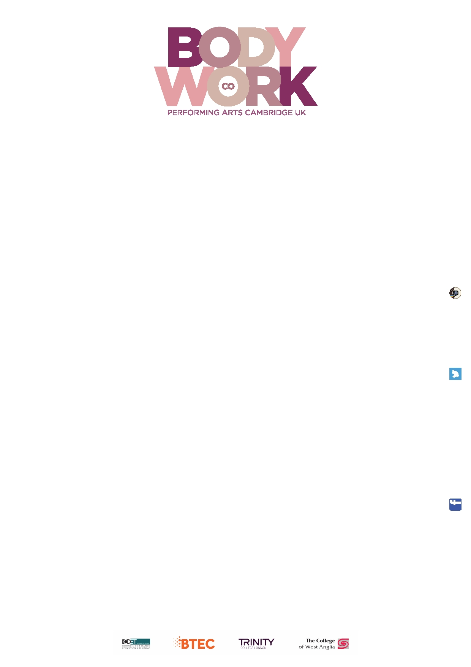

TERM DATES ACADEMIC YEAR 2018-19

Autumn Term 2018
Monday 10th September Foundation students
Tuesday 11th September 1st years plus any NEW 2nd & 3rd years
Thursday 13th September 2nd and 3rd years return
Thursday 18th October OPEN DAY for NEW prospective students
22nd – 26th October Half-Term
Thursday 8th November OPEN DAY for NEW prospective students
Thursday 6th December OPEN DAY – families of current students
Thursday 6th December Carol Concert
Friday 7th December Performing Arts Christmas Show
End of Term
Spring Term 2019
Monday 7th January Start of spring term
18th – 22nd February Half-Term
Friday 29th March End of term

Summer Term 2019
Tuesday 23rd April Start of summer term
Monday 6th May Bank Holiday
27th May – 31st May Half-Term
Friday 5th July End of term

Please note that the end of year show will be on Friday July 5th & Saturday July 6th 2019.
The 3rd year Graduation Ball will be on Sunday 7th July 2019.

Bodyworkcompanydancestudios
INST
@BodyworkDance
Bodywork Company Dance Studios

Bodywork Company Dance Studios, 25-29 Glisson Road, Cambridge CB1 2HA
Telephone: 01223 314461 • Email: admin@bodyworkds.co.uk • Web: www.bodyworkcompany.co.uk

